Software Requirements Specification

for

Model Student

Version 4.0 approved

Prepared by

Table of Contents

Table of Contents ii

Table of Figures iii

Revision History iii

1. Introduction 1

1.1 Purpose 1

1.2 Intended Audience 1

1.3 Product Scope 1

1.4 References 1

2. Overall Description 3

2.1 User Objectives 3

2.2 Product Functions 3

2.3 Operating Environment 3

2.4 Similar System Information 3

2.5 User Characteristics 5

2.6 Design and Implementation Constraints 5

2.7 Assumptions and Dependencies 6

3. Functional Requirements 7

3.1 System Requirements 7

3.2 Use Cases 9

4. External Interface Requirements 14

4.1 User Interfaces 14

4.2 Hardware Interfaces 15

4.3 Software Interfaces 15

5. Nonfunctional Requirements 15

5.1 Performance Requirements 15

5.2 Software Quality Attributes 15

6. Diagrams 16

6.1 Activity Diagram 16

7. Operational Scenario 20

7.1 Successful Scenario 20

7.2 User Manual 20

Appendix A: Glossary 26

Appendix B: Analysis Models 26

# Table of Figures

Figure 2.4-1 This shows the main screen. 4

Figure 2.4-2 This shows the menu to select game. 4

Figure 2.4-3 This shows the color and shapes game. 4

Figure 2.4-4 This shows the words game. 4

Figure 2.4-5 This is the main screen. 5

Figure 2.4-6 This is the initial screen of the game. 5

Figure 2.4-7 This is the solution. 5

Figure 2.4-8 This is the main screen. 5

Figure 2.4-9 This is the game select screen. 5

Figure 2.4-10 This is the game play screen. 5

Figure 2.4-11 This is the main screen. 5

Figure 2.4-12 This is the directions screen. 5

Figure 2.4-13 This is the game play screen. 5

Figure 3.2.1 Use Case Diagram 9

Figure 6.2.1 Select Game and Select Level Activity Diagram 17

Figure 6.2.2 Play Game Activity Diagram 18

Figure 6.2.3 Exit Level and Quit Game Activity Diagram 19

Revision History

|  |  |  |  |
| --- | --- | --- | --- |
| Name | Date | Reason For Changes | Version |
| Gon Choi  Supraja Naidu Chau Nguyen Michael Ratsamy | September 11, 2013 | Initial Draft | 1.0 |
| Gon Choi | October 2, 2013 | Incorporate comments after teacher review | 2.0 |
| Gon Choi | October 7, 2013 | Insert table of figures | 2.1 |
| Gon Choi | November 6, 2013 | Update Diagrams | 2.2 |
| Gon Choi | December 14, 2013 | Update Use Cases, Diagrams, and Operational Scenario section | 3.0 |
| Gon Choi | December 16, 2013 | Update User Manual | 4.0 |

# Introduction

## Purpose

This Software Requirements Specification (SRS) details the descriptions of the requirements of our software application, known as Model Student, in order to capture the needs and desires of the customer. This SRS establishes an agreed upon set of requirements for the development of Model Student.

## Intended Audience

The intended audience for this document is Dr. Lidia Morrison, the members of group D (Gon Choi, Supraja Kolli Somasundaram, Chau Nguyen, and Michael Ratsamy) and the customer. This document will provide a clear understanding of the game to the customer and Dr. Lidia Morrison while providing a guideline for the members of group D to develop the game. To gain an overall understanding of the game, proceed to read from the beginning of the document to the end concentrating on section 2. The intended audience of game are the kindergarten students. The game is geared towards the less fortunate students who enter kindergarten without a foundational knowledge of basic colors, numbers and words.

## Product Scope

Model Student is an educational game under the Education Software Game Systems (ESGS) product line. This game is designed to allow the students to learn how to navigate the computer system with simple levels in the game and challenging them academically as the levels progresses. As the state of California is required to implement the Common Core Standards in the near future, it is crucial that young students know how to effectively navigate and use technology. The new Common Core standards will require students to take assessments on the computer, hence teaching them how to navigate the computer device will help prepare them for the new technology dependent era in education. This game is designed to teach the students nine basic colors, numbers 1 through 10, and twenty two basic words.

## References

1. SRS Template www.csc.villanova.edu/~tway/courses/csc4700/s2008/handouts/srs_template.doc
2. CS462 Lecture Power Point presentation on Use Cases

* Deriving_Use_Cases_from_Requirements_part_1.ppt McGraw-Hill Companies, Inc.
* Deriving_Use_Cases_from_Requirements_part_2.ppt McGraw-Hill Companies, Inc.

1. Use Case Template *stlouis.iiba.org/download/UseCase.dot*‎
2. The 4Loop Team Software Requirements Specification Document

Conley, Hagood, Norvell, Wildberger. Radford University. 2011

1. [www.abcya.com/kindergarten_computers.htm](http://www.abcya.com/kindergarten_computers.htm)
2. [www.funbrain.com](http://www.funbrain.com)
3. [www.starfall.com](http://www.starfall.com)
4. [www.primarygames.com/reading.php](http://www.primarygames.com/reading.php)
5. Preschool and Kindergarten Learning Games App by Kevin Bradford
6. [en.wikipedia.org/wiki/Android_%28operating_system%29](http://en.wikipedia.org/wiki/Android_%28operating_system%29)
7. [www.android.com/](http://www.android.com/)
8. msdn.microsoft.com/en-us/library/vstudio/dd409360.aspx
9. http://freekidsbooks.org

# Overall Description

## User Objectives

The user is provided with an interactive game to learn colors, numbers and words. The user is provided with the ability to be challenged with increased level of difficulty for each type of game.

## Product Functions

The primary function of the Model Student application is to provide a set of educational learning tools. These tools are used to teach kindergarten students a set of skills required to achieve success in a Kindergarten classroom. The application is designed around a series of games which assist in learning colors, basic kindergarten mathematics and provides an introduction to reading. The game is designed to teach the user following colors: red, orange, yellow, green, blue, brown, black, white, and purple. The game is also designed to teach the user numbers 1 through 10 and the following words: boy, girl, cat, dog, ball, tree, sun cloud, flower, apple, orange, banana, milk, egg, train, car, boat, lap, fan, door, table, and chair.

The following is a list of functions of Model Student:

* Model Student provides an incremental challenge based on the subset of the game series.
* Model Student offers a user rudimentary game series before being confronted with a more taxing series of games.
* After completing a level, the user is permitted to play previously achieved levels.
* Once all of the games in a series of games has been completed, the user is able to begin another series of games from that series’ start.

## Operating Environment

Model Student is an application (app) which runs on an Android device. The Android device must have an Android Operating System (OS) version 4.1.2 or newer. Version 4.1.2 is otherwise commonly known as Jelly Bean and was released on July 9, 2012 (Source: Wikipedia). The Android OS environment provides the students with experience with one of the more widely used mobile OS. Due to the availability of multiple devices which run the Android OS, students will have greater access to this application.

## Similar System Information

There are many games which introduces students to colors, numbers and words. Many of these games are available online through a web browser. There are interactive game application on the mobile devices also.

*Preschool and Kindergarten Learning Games* App by Kevin Bradford provide a simple and easy to use interface to teach the student shapes and words. The animation and the colors make the app appealing and fun for the students.

|  |  |
| --- | --- |
| Figure 2.4-1 This shows the main screen. | Figure 2.4-2 This shows the menu to select game. |
| Figure 2.4-3 This shows the color and shapes game. | Figure 2.4-4 This shows the words game. |

There are a few games online which provide a good way of presenting the student with information and having them learn the content while having fun. Two examples from abcya.com and one from primarygames.com are examples of visually appealing and fun games to teach the student letters and words.

|  |  |  |
| --- | --- | --- |
| C:\Users\Esta\Desktop\GON\CSUF\CS462\Kindergarten web images\abcya.com.5.PNG  Figure 2.4-5 This is the main screen. | C:\Users\Esta\Desktop\GON\CSUF\CS462\Kindergarten web images\abcya.com.6.PNG  Figure 2.4-6 This is the initial screen of the game. | C:\Users\Esta\Desktop\GON\CSUF\CS462\Kindergarten web images\abcya.com.7.PNG  Figure 2.4-7 This is the solution. |

|  |  |  |
| --- | --- | --- |
| C:\Users\Esta\Desktop\GON\CSUF\CS462\Kindergarten web images\abcya.com.1.PNG | C:\Users\Esta\Desktop\GON\CSUF\CS462\Kindergarten web images\abcya.com.2.PNG | C:\Users\Esta\Desktop\GON\CSUF\CS462\Kindergarten web images\abcya.com.4.PNG |
| Figure 2.4-8 This is the main screen. | Figure 2.4-9 This is the game select screen. | Figure 2.4-10 This is the game play screen. |
| C:\Users\Esta\Desktop\GON\CSUF\CS462\Kindergarten web images\primarygames.com.1.PNGFigure 2.4-11 This is the main screen. | C:\Users\Esta\Desktop\GON\CSUF\CS462\Kindergarten web images\primarygames.com.2.PNG  Figure 2.4-12 This is the directions screen. | C:\Users\Esta\Desktop\GON\CSUF\CS462\Kindergarten web images\primarygames.com.3.PNG  Figure 2.4-13 This is the game play screen. |

The app and the websites listed in the references are similar systems which will be referenced in creation of Model Student.

## User Characteristics

Both the teacher and the students have access to the games. Different games and levels are available to the students without any limitation. All users are able to any game and any level.

## Design and Implementation Constraints

The system is limited to the Android platform. The system does not support Apple’s mobile OS (iOS). The system does not support running on a personal computer running either a Windows OS or an Apple OS. The system is designed to run on a specific subset of the different versions of Android OS which are currently released and used. The application may run on older versions of the Android OS, but it will be designed specifically to run on Android OS version 4.1.2 or newer.

The interface of the system will be limited to the touch screen. Keyboard or Mouse are not valid inputs to this system. The user will interact with the system solely through the touch screen on the device.

The games of the system will be limited to teaching the students colors (red, orange, yellow, green, blue, brown, black, white, and purple), numbers 1 through 10 and the following words: boy, girl, cat, dog, ball, tree, sun cloud, flower, apple, orange, banana, milk, egg, train, car, boat, lap, fan, door, table, and chair.

## Assumptions and Dependencies

This SRS assumes that the reader has a basic understanding of the Android Platform and the ability to navigate and operate an Android device (smartphone or tablet). This document will not discuss the requirements of the Android OS or its usability and navigability. This document will focus on the details of the application (Model Student) which will run on the Android OS.

# Functional Requirements

## System Requirements

### The system shall provide incrementally challenging levels of games.

1. Description

As the user progresses along and plays multiple levels of the games, the games progressively get more and more difficult to challenge the user.

1. Pre-Condition

None.

1. Post-Condition

None.

1. Risks

Games get too difficult to complete. Games do not get difficult, but stays in the same level of difficulty. The games go from introductory level to the hardest level too quickly (within one or two levels).

### The system shall provide a game mode.

1. Description

The system is comprised of a game mode to play games and learn colors, numbers and words while playing the game.

1. Pre-Condition

None.

1. Post-Condition

None.

1. Risks

### The system shall provide a story mode with three separate stories.

1. Description

The system is comprised of a story mode to teach the users a subset of words. Three stories will use the words the user needs to learn within the story.

1. Pre-Condition

None.

1. Post-Condition

Unlocks the words games upon completion.

1. Risks

Completion of the story mode does not unlock the words game. Story does not effectively teach the user words.

### The system shall provide a color game with six levels.

1. Description

The system consists of games that teach the user a subset of colors.

1. Pre-Condition

None.

1. Post-Condition

Color games are available to be played.

1. Risks

None.

### The system shall provide a number game with six levels.

1. Description

The system consists of games to teach the user a subset of numbers. The number games are unlocked when a subset of the color games are completed.

1. Pre-Condition

A subset of the color games have been completed.

1. Post-Condition

Number games are available to be played.

1. Risks

None.

### The system shall provide a word game with six levels.

1. Description

The system consists of games to teach the user a subset of words.

1. Pre-Condition

A subset of the number games have been completed. Story mode is completed.

1. Post-Condition

Word games are available to be played.

1. Risks

None.

### The games shall provide an introductory level to get the user familiar with the controls of the game.

1. Description

The first level of the game is designed to introduce to the user, naturally, how to play the game. The games build upon the game play which is introduced in the first level.

1. Pre-Condition

The system is launched and game mode is selected by the user.

1. Post-Condition

The first level is completed.

1. Risks

The first level is not basic enough to have the user comprehend the controls of the game. The first level is not intuitive.

### The system shall provide the ability to replay any previously played games.

1. Description

The user can play all levels and games or all previously completed levels and games.

1. Pre-Condition

None.

1. Post-Condition

All levels and games are available to be played.

1. Risks

The user will have the ability to play more difficult levels before completing the first level to introduce the content and also to navigate the application.

## Use Cases

### Use Case Diagram

The following diagram displays actors of the system and the different scenarios in which the actor may encounter when using the system. Each oval enclosed in the different rectangles are use cases which are described in details in the following sections.

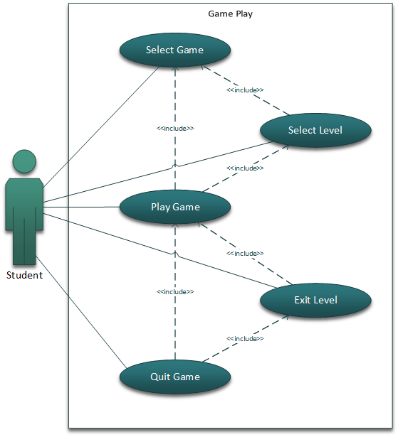

Figure 3.2.1 Use Case Diagram

|  |  |  |  |
| --- | --- | --- | --- |
| Use Case ID | Primary Actor | Use Cases | Activity Diagram |
| UC0001 | Student | Select Game | Select Game and Select Level |
| UC0002 | Student | Select Level | Select Game and Select Level |
| UC0003 | Student | Play Game | Play Game |
| UC0004 | Student | Exit Level | Exit Level and Quit Game |
| UC0005 | Student | Quit Game | Exit Level and Quit Game |

### Use Case Summary List

The table below list of the different use cases and the corresponding actors related to them.

### Actors Specification

The section describes each primary actor listed in the previous section. This is an overview of what each actor is.

1. **Student** is a user of the system who will utilize the main functions of the software.

### Use Case Specification

This section goes through each use case and provides specifications detailing who the actors are, a brief description, what triggers the use case, any preconditions or assumptions, a post condition or the expected outcome, the normal flow of how the use case will go from the trigger to the post condition, alternate flows or any deviations from the normal flow, other included use cases, and any outstanding issues generated from taking the use case into consideration.

#### Use Case: Select Game

|  |  |  |  |
| --- | --- | --- | --- |
| Use Case ID: | UC0001 | | |
| Use Case Name: | Select Game | | |
| Created By: | Supraja Naidu | Last Updated By: | Gon Choi |
| Date Created: | September 11, 2013 | Last Revision Date: | December 14, 2013 |
| Actors: | Student | | |
| Description: | The Student **shall** allow the user to select one game to play from the provided options. | | |
| Preconditions / Assumptions: | 1. System is in available state. 2. System is launched. | | |
| Post conditions: | Student successfully enters into the select game/story mode. | | |
| Normal Flow: | 1. Actor selects Play in the launch screen. 2. System displays a menu with the type of games available. 3. Actor selects the Colors game. | | |
| Alternative Flow: | 3a. Numbers Game:  3. Select the Numbers game.  3b. Words Game:  3. Select the Words game.  3c. Story Mode:  3. Select the Story Mode. | | |
| Includes: | None. | | |
| Notes and Issues | At any given time, if the Actor presses the Home button or the Power button on the android device, the Actor will exit the System and be taken to the main OS. | | |

#### Use Case: Select Level

|  |  |  |  |
| --- | --- | --- | --- |
| Use Case ID: | UC0002 | | |
| Use Case Name: | Select Level | | |
| Created By: | Chau Nguyen | Last Updated By: | Gon Choi |
| Date Created: | September 21, 2013 | Last Revision Date: | December 14, 2013 |
| Actors: | Student | | |
| Description: | The System Administrator **shall** allow the user to select a specific game level to play. | | |
| Preconditions / Assumptions: | 1. System is in available state. 2. System is launched. | | |
| Postconditions: | Level is launched. | | |
| Normal Flow: | 1. Actor selects Play in the launch screen. 2. System displays a menu with the type of games available. 3. Actor selects the Colors game. 4. System displays a menu of the levels available to play. 5. Actor selects a level. 6. System displays the level. | | |
| Alternative Flows: | 3a. Numbers Game:  3. Select the Numbers game.  4. Resume at step 4 of normal flow.  3b. Words Game:  3. Select the Words game.  4. Resume at step 4 of normal flow.  3c. Story Mode:  3. Select the Story Mode.  4. System displays a menu of the stories available to read.  5. Actor selects a story.  6. System displays the story.  3d. Exit:  3. Actor selects Cancel.  4. System displays the main menu. | | |
| Includes: | Select Game | | |
| Notes and Issues: | At any given time, if the Actor presses the Home button or the Power button on the android device, the Actor will exit the System and be taken to the main OS. | | |

#### Use Case: Play Game

|  |  |  |  |
| --- | --- | --- | --- |
| Use Case ID: | UC0003 | | |
| Use Case Name: | Play Game | | |
| Created By: | Gon Choi | Last Updated By: | Gon Choi |
| Date Created: | September 11, 2013 | Last Revision Date: | December 14, 2013 |
| Actors: | Student | | |
| Description: | Student **shall** be able to play the selected game (story mode or game mode). | | |
| Preconditions / Assumptions: | 1. System is in available state. 2. System is launched. 3. System currently displays the menu with the type of games available. | | |
| Post conditions: | Actor completely plays selected game. | | |
| Normal Flow: | 1. Actor selects the Colors game. 2. System displays a menu of the levels available to play. 3. Actor selects a level. 4. System displays the level. 5. Actor selects the appropriate button to advance to the next page. 6. System displays the next page. | | |
| Alternative Flow / Exceptions: | 1a. Numbers Game:  1. Select the Numbers game.  2. Resume at step 2 of normal flow.  1b. Words Game:  1. Select the Words game.  2. Resume at step 2 of normal flow.  1c. Story Mode:  1. Select the Story Mode.  2. System displays a menu of the stories available to read.  3. Actor selects a story.  4. System displays the story.  5. Resume at step 5 of normal flow.  5a. Game Mode End of Game:  5. Actor selects the appropriate button to advance to the menu  of the levels available to play.  6. System displays the menu of the levels available to play.  7. End of normal flow.  5b. Story Mode End of Story:  5. Actor selects the appropriate button to advance to “The End”  screen.  6. System displays the “The End” screen.  7. Actor selects anywhere on the screen.  8. System displays the menu of available stories to read.  9. End of normal flow. | | |
| Includes: | Select Game, Select Level | | |
| Notes and Issues: | At any given time, if the Actor presses the Home button or the Power button on the android device, the Actor will exit the System and be taken to the main OS. | | |

#### Use Case: Exit Level

|  |  |  |  |
| --- | --- | --- | --- |
| Use Case ID: | UC0004 | | |
| Use Case Name: | Exit Level | | |
| Created By: | Michael Ratsamy | Last Updated By: | Gon Choi |
| Date Created: | September 21, 2013 | Last Revision Date: | December 14, 2013 |
| Actors: | Student | | |
| Description: | The System Administrator **shall** create a user for the student. The expected outcome is a user **shall** be created. | | |
| Preconditions / Assumptions: | 1. System is in active state. 2. System is launched. 3. Actor selected a level. 4. Actor is currently playing a game or reading a story. | | |
| Postconditions: | User successfully exits the level or story. | | |
| Normal Flow: | 1. Actor selects the exit button within the game. 2. System displays the menu of the levels available to play. | | |
| Alternative Flows: | 1a. Story Mode:  1. Actor selects the exit button within the story.  2. System displays the menu of the stories available to read. | | |
| Includes: | Play Game | | |
| Notes and Issues: | At any given time, if the Actor presses the Home button or the Power button on the android device, the Actor will exit the System and be taken to the main OS. | | |

#### Use Case: Quit Game

|  |  |  |  |
| --- | --- | --- | --- |
| Use Case ID: | UC0005 | | |
| Use Case Name: | Quit Game | | |
| Created By: | Michael Ratsamy | Last Updated By: | Gon Choi |
| Date Created: | September 11, 2013 | Last Revision Date: | December 14, 2013 |
| Actors: | Student | | |
| Description: | The Student **shall** be able to quit the game | | |
| Preconditions / Assumptions: | 1. System is in active state 2. System is launched. 3. System displays the menu with the type of games available. | | |
| Post conditions: | Actor successfully quits the system | | |
| Normal Flow: | 1. Actor selects Cancel. 2. System displays the launch screen. 3. Actor selects the Home button on the android device. 4. System exits the application. | | |
| Alternative Flow / Exceptions: | 3a. Power Button:  3. Actor selects physical power button on the device.  4. System exits to Operating System.  5. Operating System goes on standby mode.  1c. Select Game Submenu:  Actor completes level  System displays Select Game submenu  Actor selects quit  System displays main menu | | |
| Includes: | Play Game, Exit Level | | |
| Notes and Issues: | At any given time, if the Actor presses the Home button or the Power button on the android device, the Actor will exit the System and be taken to the main OS. | | |

# External Interface Requirements

## User Interfaces

The user interface shall consist of buttons, colors, numbers, words and pictures. The application shall utilize the touch screen to get input from the user and provide graphical and audible feedback to the user. The GUI shall consist of a main menu, submenus, a color game, a number game, a word game, and graphical stories. All menus shall consist of buttons which allow the user to navigate the system.

## Hardware Interfaces

The users of the system shall have a device (smartphone or tablet) which runs the Android OS and meets the minimum specification requirements. The device shall have a functioning touch screen, a function speaker and a functioning camera.

The device shall have the following minimum specifications:

* + 1 GHz CPU
  + 512 MB RAM
  + 1 GB Internal Storage

## Software Interfaces

The users of the system shall have the stated Android OS version.

# Nonfunctional Requirements

## Performance Requirements

The system shall take 20 seconds or less to initially load the application. The system shall take 15 seconds or less to load a new level. The system shall take 10 seconds or less to load a story.

## Software Quality Attributes

### Compatibility

The system shall run on all Android OS specified.

### Maintainability

The system shall be accompanied by a design document and other documentation for use during maintenance of the software. The system shall be implemented based on the design in order to make future updates and additions to the software easier.

# Diagrams

## Activity Diagram

The following are activity diagrams that visually explains the actions that may be taken in the stated scenario. The solid turquoise circle is the starting point and the yellow circle with a ring around it is the ending point. The rectangular shapes are actions or activities that are taken while the diamonds are conditional checks which can split the process one way or another. These are all connected via directional lines which produce a flow of events. The solid red rectangular bars are fork nodes which breaks the flow into multiple flows of events that happen simultaneously. The vertical rectangular lanes that encompass all the actions / activities are called swim lanes. These separate the actions into lanes which defines who’s performing the actions.

### Select Game and Select Level

This activity diagram shows steps involved in selecting the game to play and selecting a level. For the game mode, there will be 6 levels per type of game and the story mode will have 3 stories to choose from.

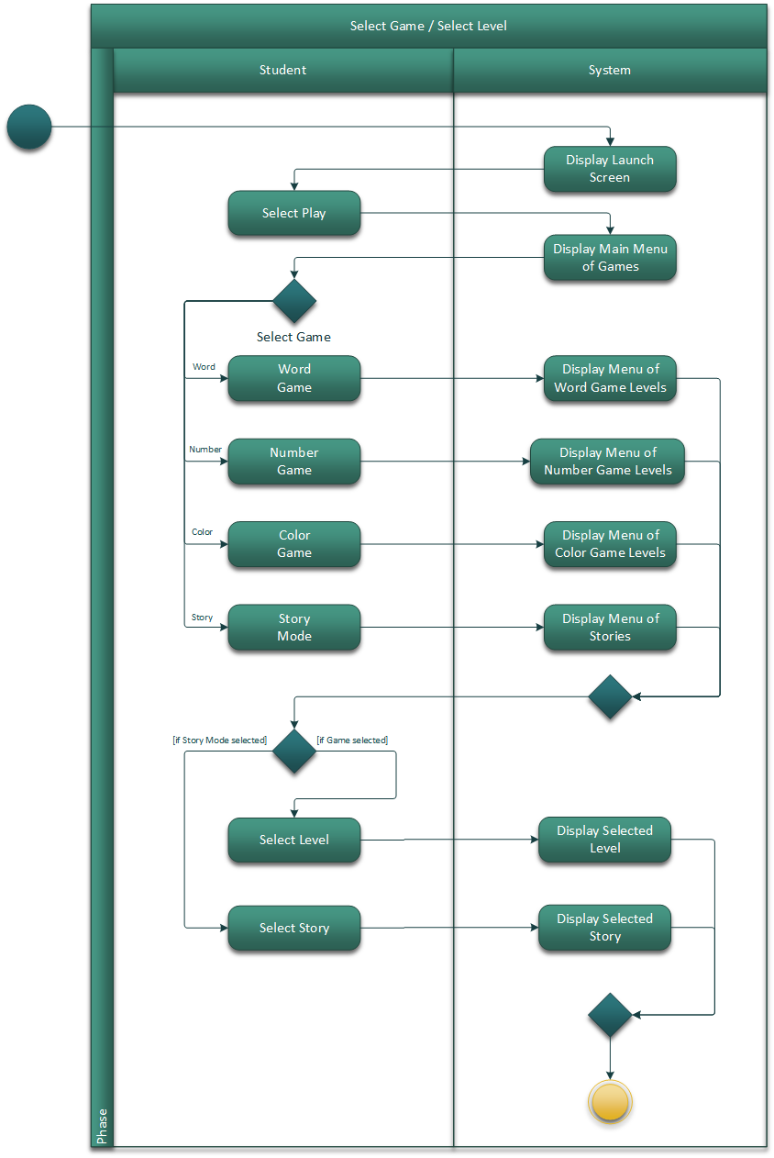

Figure 6.2.1 Select Game and Select Level Activity Diagram

### Play Game

This activity diagram shows steps involved in playing the game. Playing the game can be comprised of playing a word, number or color game, or reading a story. This take input from the Select Game and Select Level activity diagram above.

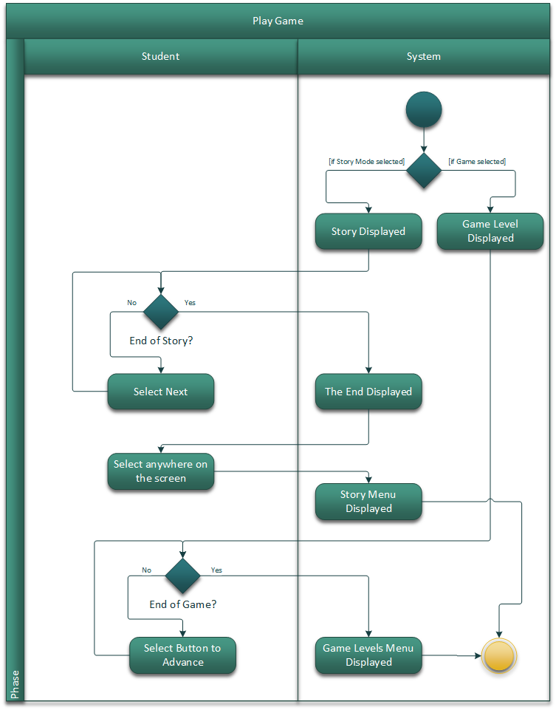

Figure 6.2.2 Play Game Activity Diagram

### Exit Level and Quit Game

This activity diagram shows steps involved in exiting the level or quitting the game. A Student will have the option to exit a level or quit the game at any given time either through the game’s navigation buttons or through the android Home button or the Power button.

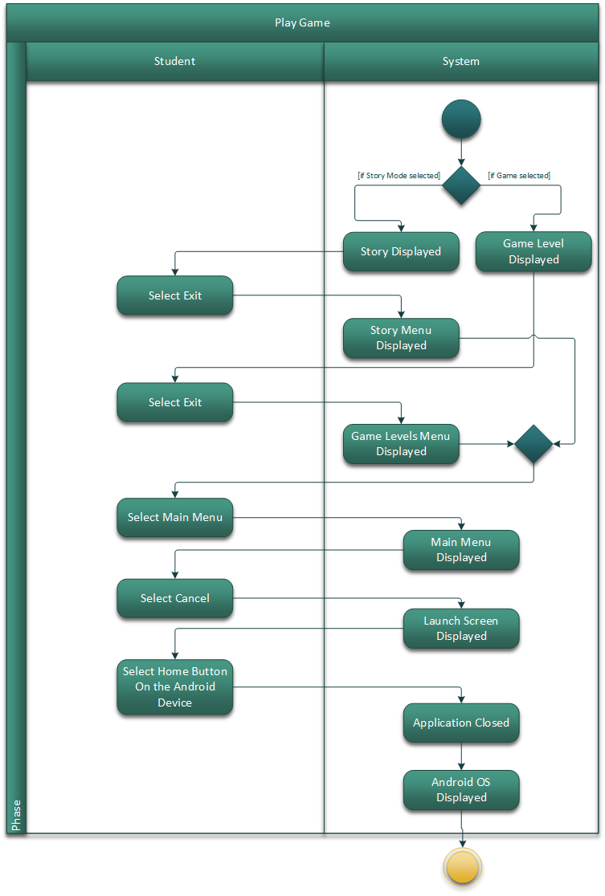

Figure 6.2.3 Exit Level and Quit Game Activity Diagram

# Operational Scenario

## Successful Scenario

In a successful scenario, the user of the system will log into the application, select a game to play and play the game. The games will consist of a colors game, a numbers game and a words game. For each game, the user will be asked to identify a specified color, number or word and a subset of these items will be displayed on the screen. Upon a successful selection of the requested color, number or word, the user will be notified that the selection is correct. Upon an unsuccessful selection of the requested color, number or word, the user will be notified that the selection is incorrect and then prompted to retry with another selection. There is also be a story mode where the user will be able to view and listen to stories and learn words which will be used during the words game.

## User Manual

1. To being, **Select** Play in the Launch Menu.

|  |
| --- |
| C:\Users\Esta\Google Drive\cs462_Final\Screenshots\MainActivity.PNG  Figure 7.2-1 Launch Menu |

1. The navigation between the different types of games are similar. We will explore using the Color world as an example for the game mode and Nat the Cat as an example for the Story Mode. We will start with the game. **Select** the Color Game to play.

|  |
| --- |
| C:\Users\Esta\Google Drive\cs462_Final\Screenshots\MainMenu.PNG  Figure 7.2-2 Main Menu |

1. Six levels will be displayed. From the six, **Select** Game 1. Game 1 is an introductory level and will intuitively teach the user how to navigate through the application.

|  |
| --- |
| C:\Users\Esta\Google Drive\cs462_Final\Screenshots\ColorWorld.PNG  Figure 7.2-3 Color World |

1. The game will prompt you with a question or a challenge to select the correct button. **Select** the correct button to advance to the next page.

|  |
| --- |
| C:\Users\Esta\Google Drive\cs462_Final\Screenshots\ColorGame1.PNG  Figure 7.2-4 Color Game |

1. If you are at the end of the level, you will be brought back to the Level Selection Menu. Additional levels can be selected to play or the main menu option can be selected.

This time we will explore the story mode navigation. **Select** the Story Mode.

|  |
| --- |
| C:\Users\Esta\Google Drive\cs462_Final\Screenshots\MainMenu.PNG  Figure 7.2-5 Main Menu |

1. Three stories will be listed. From the list, **Select** Nat the Cat.

|  |
| --- |
| C:\Users\Esta\Google Drive\cs462_Final\Screenshots\StoryMenu.PNG  Figure 7.2-6 Story World |

1. The title page will be displayed with a button to navigate to the right to advance to the next page.

|  |
| --- |
| C:\Users\Esta\Google Drive\cs462_Final\Screenshots\StoryTitle.PNG  Figure 7.2-7 Nat the Cat Title Page |

1. In the story mode, there are a few buttons to be mindful of. From this page, you can navigate back to the previous page, advance to the next page, or exit to the Story Selection Menu.

|  |
| --- |
| C:\Users\Esta\Google Drive\cs462_Final\Screenshots\StoryPages.PNG  Figure 7.2- Nat the Cat Story |

1. If you keep on advancing until the end of the story, “The End” page will be display. Select anywhere on the screen and this will advance you back to the Story Selection Menu.

|  |
| --- |
| C:\Users\Esta\Google Drive\cs462_Final\Screenshots\StoryTheEnd.PNG  Figure 7.2-9 Story The End Page |

1. From the Story Selection Menu, Select Main Menu. This takes you back to the Main Menu to play games or read stories.

|  |
| --- |
| C:\Users\Esta\Google Drive\cs462_Final\Screenshots\StoryMenu.PNG  Figure 7.2-10 Story World |

1. You now have the general idea on how to navigate Model Student. Happy Learning!

# Appendix A: Glossary

|  |  |
| --- | --- |
| Acronyms | Definitions |
| CPU | Central Processing Unit |
| ESGS | Education Software Game Systems |
| GUI | Graphical User Interface |
| OS | Operating System |
| RAM | Random Access Memory |
| SRS | Software Requirements Specification |
| UI | User Interface |

# Appendix B: Analysis Models

None